Me.Mu and Emotionary

Socio-emotional Learning Through Play and Reflection

Hain-Lee Hsueh

Anna Ly

# Abstract

In this report we present two candidate solutions for helping people with autism develop socio-emotional thinking and skills. Our target audience comprises of children or adolescents with mild to moderate autism or similar mental disorders. Knowing that individuals on the spectrum exhibit social skill deficits, our learning goal is to strengthen their understanding of emotions to develop socio-emotional skills and behaviors.

We have developed a pair of mini-games on the Kinect (branded as Me.Mu) and an iPad emotion diary app (called Emotionary). Me.Mu provides opportunities for learners to actively practice emotion recognition and greetings in a simulated environment. Emotionary encourages awareness and understanding of emotions in the context of the learners’ own lives. Both applications are meant to be used with a therapist or adult who will encourage and prompt the child.

The applications were developed with a user-centered design process, in which therapists, parents, and children were active participants. The latest iterations were piloted at the Pacific Autism Center for Education (PACE). A speech therapist facilitated multiple group sessions with Me.Mu while video, scores, and an assistant recorded notes. A teacher and other staff used Emotionary in short one-on-one sessions. To assess preliminary effectiveness of Me.Mu, we looked at raw scores and observation notes for individual students over multiple sessions, as well as video evidence of improvement and engagement. For Emotionary, we looked at the entries that students created to see if emotions could be connected to specific events.

Based on positive feedback from reviewers, we will publish Emotionary on the Apple Appstore to reach a wider audience that includes individuals with various emotional disabilities, and continue developing Me.Mu perhaps in collaboration with PACE.

# Introduction

Autism spectrum disorders (ASD) and autism affect many people in the world. According to the U.S. Centers for Disease Control and Prevention, 1 in 110 American children are on the autism spectrum (Autism Speaks, 2012). Astonishingly, more children this year will be diagnosed with autism and ASD than with cancer, diabetes, and pediatric AIDs combined. More than 3 million individuals in the U.S. and 10 million individuals world-wide are diagnosed with ASD and autism.

Autism and autism spectrum disorders (ASD) are general terms encompassing a larger group of brain developmental disorders. The criteria for autism listed in the Diagnostic and Statistical Manual (DSM IV being the most recent version at the time of this writing) include impairments in social nonverbal behaviors (e.g. eye gaze, facial expressions, posture), difficulty in developing peer and reciprocal relationships, language delay, and repetitive patterns of behaviors and motor mannerisms (American Psychiatric Association, 2000).

A speech therapist we interviewed mentioned that her students had difficulty “imitating facial expressions…they sometimes over-exaggerate so it looks unnatural.” We also interviewed a mother of a 5-year-old son with autism. For him, communication and appropriate facial expressions were two difficulties.

Many of the criteria and signs of autism are related to social skills and behaviors. As a result, despite potentially having at least comparable academic and mental ability as typically developing peers, individuals with autism can experience social isolation and lack of peer relationships.

# Background Research and Theory

From our general research and experience, there seemed to be two dominant approaches that address two general aspects of social skills. The first is a behavioral (but not necessarily behaviorist) approach, where the focus is on teaching or shaping behaviors and interactions. The second approach is more cognitive, where the focus is on directly developing mental understanding and thinking.

Often the goal of the behavioral approach is an external outcome, such as teaching kids how to play with a peer, or how to initiate reciprocal interaction. Although numerous studies have shown the effectiveness of a behavioral approach (in which modeling is a common technique), there have been concerns as to whether the participants are learning how to genuinely be social or if they are just going through the motions of say, what a playful interaction outwardly looks like (Koegal & Koegal, 1995, Strain et. al, 2011, Schriebman, 2007, Luckett et. al, 2007).

Nevertheless, one study we found showed that combining verbal behavior with a modeling approach using multiple exemplars can increase mastery of a behavior and likelihood of behavioral transfer (Jahr et al, 2000). It is possible that the verbal behavior, which prompted the participants to describe what was happening in a modeled play scenario, facilitated development of metacognition, encouraging them to be aware of their own actions and how they responded to the actions of others (and vice versa).

This lead us to favor a cognitive approach. According to Baron-Cohen (2009), empathy can be divided into two components: 1) a cognitive one (recognition of a person’s mental state) and 2) an affective one (emotional reaction to another person’s mental state). Intervention studies involving the use of Mindreading and The Transporters series (briefly described later) have shown that it is indeed possible to teach at least the cognitive component of empathy to individuals with autism. Additional research has yet to determine whether the affective component can also be taught (Baron-Cohen et al, 2009). These findings provided some potential insights and implications for design.

Another theoretical framework that influenced our approach is Social Thinking, a term coined by Michelle Garcia-Winner, a speech language therapist who specializes in treating individuals with social-cognitive deficits. Social Thinking postulates that because social skills are situational and dynamic, one must be able to dynamically process social decisions. Successful social thinking happens when the individual can deliberately consider his or her own speech, behavior, and physical presence, and how they affect the emotions and thoughts of others. Winner developed a curriculum and treatment framework that targets teaching those social thinking skills (Winner, 2012).

Based on this research and interviews, we developed a target learner group and learning problem: Children or adolescents with mild to moderate autism need to strengthen their understanding of emotions to develop socio-emotional skills and behaviors because failing to do so may lead to social isolation as well as delayed cognitive and social development.

# Existing Solutions

Through observations at different centers, as well as interviews with therapists and parents, we identified several popular applications and tools for socio-emotional development:

1. **Mind Reading**: Designed by team at Cambridge University led by Professor Simon Baron-Cohen, Mind Reading is a software application for exploring and learning over 412 different emotions. The expansive database includes an emotion library, games as well as ministories, vocabulary and cultural references. Most of the vocabulary and references are specific to the U.K.



Figure 1: Mindreading software serves as an encyclopedia.

1. **The Transporters**: This is a DVD animation series that teaches emotion recognition. It is also produced by a team led by Professor Simon Baron-Cohen. The series combines autistic children’s propensity for predictable systems, by using trains as the main characters, with unpredictable systems, by putting realistic human faces on the front of the trains.



Figure 2: The Transporter DVD series featuring human faces grafted on vehicles.

1. **Feel Electric**: “Feel Electric!” is an iPad app that explores different emotions including delight, happy, sad, astonished, and anxious. It was developed to help children in Military families cope with their loved ones being far away. The app offers engaging tools that use content and curriculum from The Electric Company to provide opportunities to explore emotional vocabulary and self-expression. There are three interactive games, a digital diary to record your moods each day, a story builder, etc.

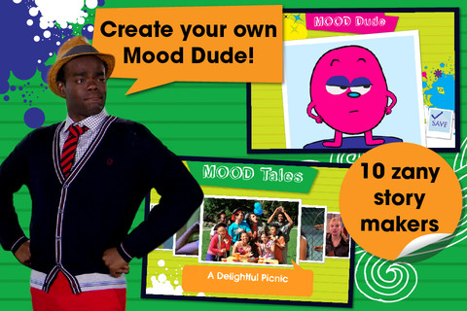

Figure 3: Feel Electric iPad app with interactive games and a mood diary.

1. **Flashcards**: Therapists showed us examples of flash cards that they use with the children to teach social skills and emotions. The sets range from cards that match with scenarios to cards that just have a demonstration of the emotion. Their use varied; some therapists used them to teach the emotion, others used them to encourage the child to mimic the facial expression and others had the students use them to act out scenarios or explain their feelings at that moment.



Figure 4: Example of a flashcard set.

1. **Picture books**: We also found sets of picture books at the centers. Some of them were familiar to the flashcards, in which they just showed a library of emotions. Others were story-based and showed cars and trains or realistic photos of kids in common social situations, sometimes explicitly prompting the reader to think about what they are reading and seeing on the page.

|  |  |
| --- | --- |
| http://ecx.images-amazon.com/images/I/51tbb0W7bsL._BO2,204,203,200_PIsitb-sticker-arrow-click,TopRight,35,-76_AA300_SH20_OU01_.jpg | http://graphics8.nytimes.com/images/2011/04/21/books/review/21artsbeat-autism/21artsbeat-autism-articleInline.jpg |

Figure : Examples of picture books related to social skills.

From our interviews, we also discovered another common approach to teaching behaviors and social skills. Rather than cards or books, the therapist would show video scenarios. During an observation of a class at the Arbor Bay School the instructors showed a Shaun the Sheep video and paused it at key moments to ask contextual questions such as “How does Shaun feel now since his car broke down?” Another therapist used videos of the kids themselves to remind them of how they felt at a certain moment and to reflect on their actions. By using popular characters or video footage of the students, the therapists were able to engage the students’ attention for a longer period of time.

# Approach

Based on our empathy work and research, we developed a set of design principles, some of which came about later in the process:

1. **No negative feedback**: When observing children interact with tablet apps, we noticed that some of them would just hit all of the buttons and icons until there was some type of feedback. Even if it were negative (e.g. character blowing up), the child would be so attracted to that visual response that he would just keep trying to get negative feedback.
2. **Make things realistic**: This principle came about when multiple therapists provided feedback on several of our ideas. They mentioned that individuals with autism have trouble identifying themselves with unrealistic situations, especially ones that they’ve never encountered.
3. **Emphasis on body movement for the Kinect apps**: In one of our earlier prototypes, hand movements were used only to navigate the Kinect application. Although the prototype was positively received by therapists, industry reviewers questioned whether it leveraged the Kinect’s unique affordances.
4. **Therapist facilitation**: This set up also ensures that the child with autism receives tailored assistance for different disabilities, and also encourages more collaboration.
5. **Toolkit approach and flexibility**: Because children with autism often have individual and unique strengths, deficits, and preferences, we opted for a toolkit approach so that more kids with varied needs can potentially benefit from this solution.
6. **Personalization**: Personalization was an aspect we felt technology could readily facilitate. It is also notable that personalization is missing from other solutions such as Mindreading, Transporters, and flashcards.

# Design Methods

We decided to use the Stanford d.school Design Thinking process (Empathy > Define > Ideate > Prototype > Test) to guide our project for this course. Design notebooks were used to capture notes, random ideas, and drawings.

|  |  |
| --- | --- |
| Figure : d.school process | Figure : Design notebook |

Because we did not have background knowledge about autism, we conducted online research and informal interviews to get an understanding of autism in general and to see what technologies and solutions were being used. Based on our findings, we did several rounds of brainstorming sessions using post-it notes and whiteboards. From there, we clustered similar ideas into groups and voted for our favorite ideas.

|  |  |
| --- | --- |
|  |  |

Figure : Brainstorming sessions.

Next, we took our favorite ideas and prototyped them using methods taught to us in CS 377i: Prototyping Interactive Systems. We defined interaction points for the different design concepts and created quick 30 second or less video sketches. We reviewed the video prototypes with therapists who helped refine the ideas behind them, which we later turned into more hi-fi prototypes on the iPad and Kinect. We iterated several times based on feedback and observations in testing. Although the design thinking process seems linear, our ultimate process was circuitous, in which we would go back to do more interviews and ideating.

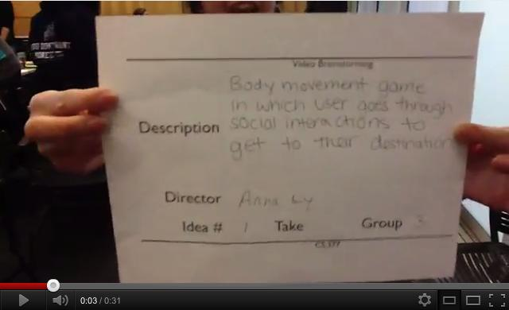

Figure 9: Video prototyping.

# Solution

## Concept Video Prototypes

One of the things that surprised us from our interviews was that learners were not always able to show or express their feelings on their faces, an ability that is largely automatic for most people. Noticing that many solutions focused on recognition of emotions, we thought it would be interesting to come up with an idea that focused on expression of emotions. One idea we fleshed out was for the Kinect. Two players would participate by watching a cartoon scenario with two bears. At key events, the game would prompt one of the players to show how one of the bears feels at that moment. The player would respond by making the facial expression corresponding to the emotion. A core part of this idea was using the Kinect to perform facial emotion recognition. In addition to this, players could practice turn-taking and social interaction with the other peer.

We created a video prototype of this concept and shared it with therapists. Their main feedback to us was the following:

* It needed to be more realistic - learners would not be able to transfer from bears to real people
* More emphasis on the context of an emotion was needed
* It would be better to have the therapist or an adult facilitate, rather than another learner on the spectrum

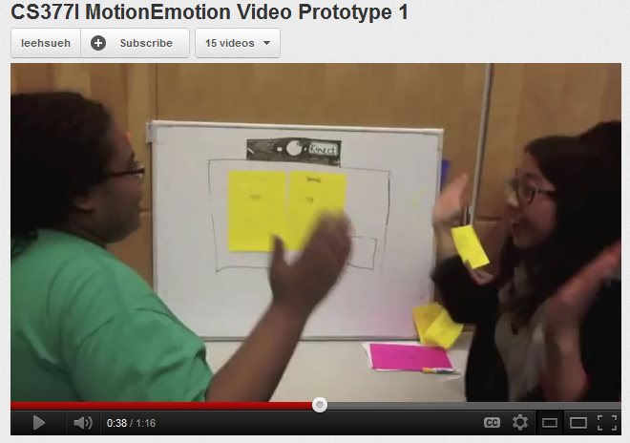

Figure 10: Initial video prototype with cartoon bears.

As a result of this feedback, we developed a second video prototype that used videos of real people instead of bears. We also thought videos were an excellent medium for illustrating a context of an emotion. The general flow of the activity was as follows:

1. Cooperating with the therapist, the learner would select a video to watch from a list by moving his/her hand to manipulate a cursor on the screen
2. The screen would prompt the learner to pay attention to the main character as a scenario unfolds
3. After the video ends, the learner is prompted to identify what emotion the main character is feeling (again, manipulating the on-screen cursor to choose the answer) - this was to encourage learners to extract relevant contextual cues from the video to imagine how the character might be feeling
4. Upon selecting the correct emotion, the learner would construct a facial expression showing that emotion by choosing appropriate sets of eyes, nose, and mouth - this was meant to draw attention to specific facial features
5. Lastly, the learner is prompted to take a photo of him or herself making an appropriate facial expression for that emotion - this gives the learner opportunity to practice and get familiar with how it feels expressing a particular emotion

|  |  |
| --- | --- |
| Figure 11: Viewing a video | Screen Shot 2012-08-01 at 7.04.45 PM.png  Figure 12: Selecting the emotion |
| Figure 13: Building a facial expression | Screen Shot 2012-08-01 at 7.07.20 PM.png  Figure 14: Making a facial expression |

We hit a roadblock, however, when trying to determine how to incorporate facial emotion recognition. Despite emerging start ups and software libraries in this area, we decided the requisite engineering was not worth our time or effort. Furthermore, we realized that people are very good at assessing facial expressions and might be in a better position to fulfill that function than the technology. Thus, we decided to offload the task of assessing facial expressions to the therapist.

Once we made that decision, we realized our idea was not making compelling use of the Kinect. We were not leveraging the Kinect’s ability to track a person’s body and movement in 3D space. At this juncture, we thought the idea could work on a tablet and decided to develop a functioning prototype on the iPad. At the same time, we wanted to continue thinking about ideas that did leverage the Kinect because we felt that there was a lot of potential for impact in the autism space. As a result, our project ended up pursuing two solutions on two different platforms.

## First iPad prototype

Our first functional prototype on the iPad was a direct translation from our video prototype, except that navigation of the app was achieved through tapping instead of manipulating a virtual cursor on the screen. Screenshots of the flow are shown below.

|  |
| --- |
| IMG_0406.PNGIMG_0407.PNG |

Figure : Screenshots of 1st iPad prototype

We tested this prototype with two therapists, and although the feedback was generally positive, we observed that how it was used was not all that different from how therapists were already using video. The core interaction appeared to be playing/pausing the video at certain times, and facilitating a discussion to help learners process what is happening and how that affects what the characters are feeling. Our app did not appear to add much additional value to this interaction.

Nevertheless, we were able to more clearly identify key strengths that we wanted to preserve and build upon:

1. Guiding attention to contexts of an emotion
2. High engagement with the camera and taking photos of oneself
3. Documenting and tracking progress through storing and tagging of photos of the learners

We asked ourselves if we could design something different that was more novel than a video-based app, but still maintains the previously mentioned strengths. During this period we had an insight for a different direction: what if we had learners reflect on and learn about emotions from their own experiences, rather than from external or hypothetical scenarios? This led to the development of our current iPad solution.

## Emotionary

Emotionary is an emotion diary tool that helps learners become aware of emotions in context through scaffolded reflection. Each learner maintains a diary where each entry is framed as two short prompts: “How do I feel today” and “Why do I feel that way.”

|  |
| --- |
| iOS Simulator Screen shot Jul 24, 2012 10.34.39 AM.png IMG_0400.PNG |

Figure : Prompts from Emotionary

In creating a new entry, the learner first identifies the emotion they are feeling. Next, the learner is prompted to express that emotion on his or her face so they can practice communicating how they feel. Finally, they respond to the question of why they feel that emotion. This response can be in the form of an audio recording in which they verbalize an explanation, an image/photo that is stored on the iPad that captures some contextual information, or a typed response. Multiple options were provided for flexibility so that, for example, a non-verbal student could still communicate their thoughts by typing.

|  |  |  |
| --- | --- | --- |
| iOS Simulator Screen shot Jul 24, 2012 10.34.50 AM.png | iOS Simulator Screen shot Jul 24, 2012 10.35.09 AM.png | iOS Simulator Screen shot Jul 24, 2012 10.35.13 AM.png |

Figure : Options for responding to the prompt "I feel [emotion] because..."

The goal of the entry creation process is to have learners practice extracting contextual information from their personal experiences and connecting them to how they feel at a certain time. In this way, they can always relate to the context because it is from their own lives, not from someone else’s.

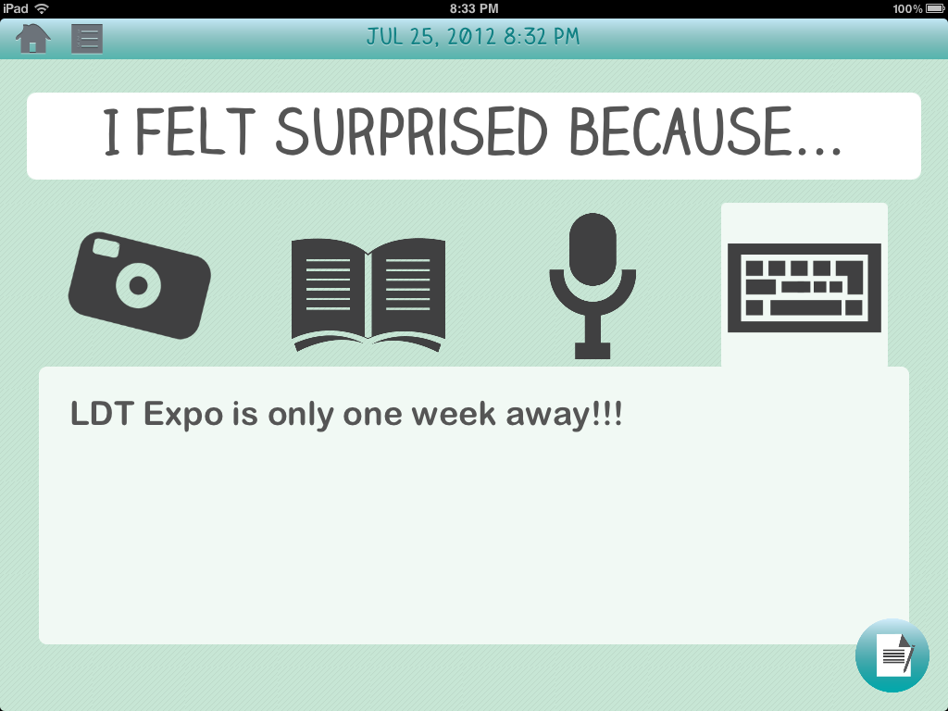

Figure 18: Example of an entry giving context to feeling surprised.

Furthermore, the entries serve as data that can be used to document and track the progress of a learner’s emotional awareness and ability to communicate his or her feelings. The therapist or adult can easily show a learner’s progress and potentially use the data to create more personalized instruction.

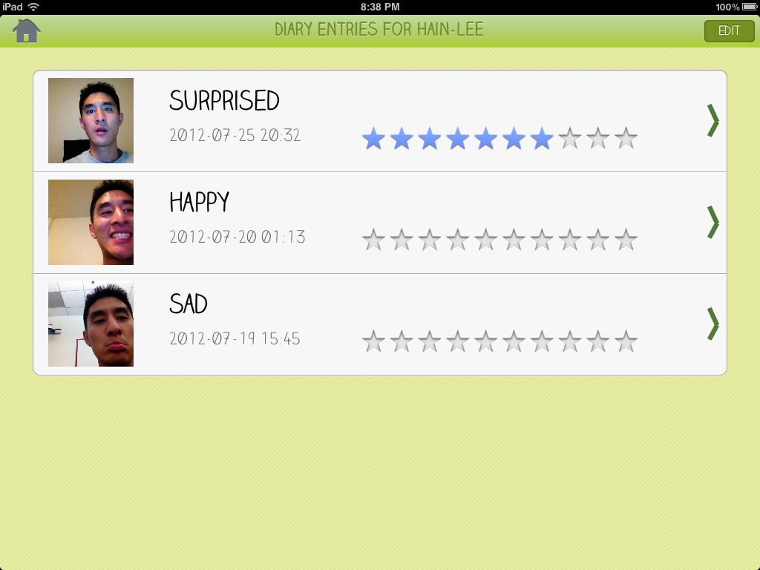

Figure 19; Overview of a student's entries, and ratings given by the therapist.

A teacher who tested Emotionary with some of her students commented that although students are often asked, “How do you feel,” they were more excited and more willing to express themselves using the iPad. In addition, she said it really provided an avenue for students to discuss emotions that they were unfamiliar with, such as disgusted.

## Me.Mu

Going back to the Kinect, while brainstorming new ideas, we drew inspiration from Juan Pablo Hourcade, an Associate Professor of Computer Science at the University of Iowa, and his toolkit approach of developing multiple computer-based activities for individuals with autism. When testing his suite of activities with learners, he confirmed that by providing multiple different mini-activities, he was able to engage more users with varying interests and preferences (Hourcade et al, 2011).

We brainstormed several ideas for mini-activities for the Kinect and ended up developing two, which we call “Falling Faces” and “Hello Park.”

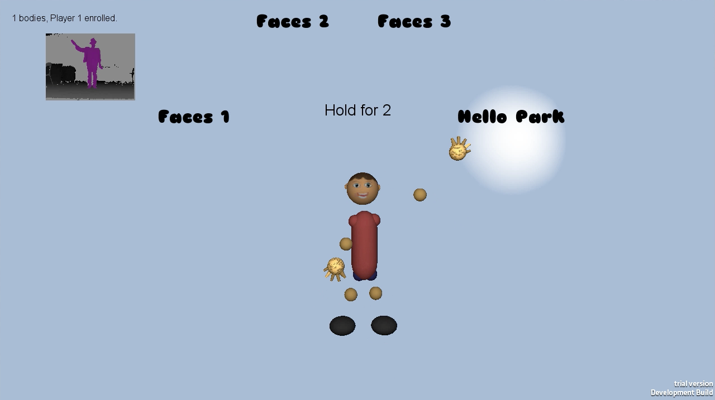

Figure 20: Main menu showing the available games and levels.

“Hello Park” provides a simulated environment where the learner’s avatar is situated in a park where people are walking by. The game prompts the learner to pinpoint a specific person in the park (“James”) that they should greet by performing a hand-wave. If the learner waves to the “wrong” person, then that character simply walks off the screen at a faster pace. If the learner waves to “James,” then that character will respond by waving back. The purpose of this game is to provide a less stressful environment for learning and repeated practice of a proper physical greeting. The hope is that when learners become comfortable with physically carrying out a greeting, they will be more likely to execute it in real life.

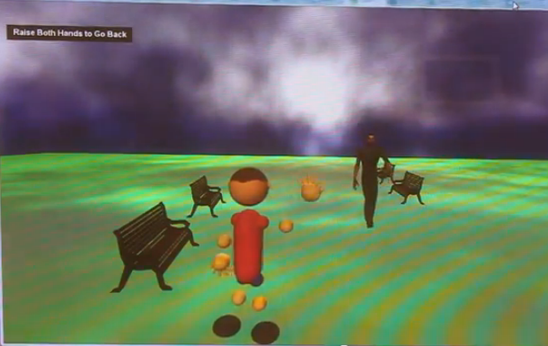

Figure 21: Screenshot of Hello Park

“Falling Faces” is intended to be less of an instructional activity and more of a “movement break” for learners. Since some of the therapists we interviewed talked about the importance of play and physical movement in general, we wanted to create an activity that gave the learners license to move around. To give the activity some structure and an objective, we incorporated an emotion recognition task. During the game, two spheres fall from the sky. In the first level, one sphere is blank and the other has a face; the objective is to touch the sphere with the face. In subsequent levels, both spheres have a face and the objective is to touch the sphere with the face that matches a particular emotion. In the last level, faces are shown in black and white rather than color. To touch a sphere, the learner is required to move towards one side or the other. When the correct face is touched, the sphere explodes, which is intended to serve as positive and rewarding feedback. If the wrong sphere is touched, both spheres simply fall below the screen, which aligns with our principle of leaving out negative feedback.

|  |  |
| --- | --- |
|  |  |

Figure 22: Levels of Falling Faces. First level just focuses on faces, and subsequent ones require distinguishing emotions.

Although Falling Faces was not intended to be an instructional activity, one therapist noted that she liked it because it helped students perform emotion recognition in real-time. In typical therapy activities, students are shown flashcards of facial expressions and have the luxury of looking at them for a relatively extended period of time. Thus, the game provided an environment to help increase their processing speed of facial expressions.

The nature of Kinect games also provides an occupational therapy benefit because it requires learners to manipulate specific parts of their bodies at will. In the main menu, learners must raise one of their arms at particular degrees in order to make a selection. This enables them to practice exercising more precise control over their bodies.

# Learning Theories

Looking back at Me.Mu we found that there are three primary learning theories that underlie the games. The first one is **embodied learning**, which is the idea that learning is facilitated through our bodies interacting in real time and real space (e.g. learning how to walk). This is reflected in “Hello Park,” which teaches how to wave to people repetitively so that the gesture can become ingrained and automatized. In general, the games on the Kinect encourage movement helps learners get in touch with their bodies and may make them better prepared for learning social body language (i.e. occupational therapy benefits).

Another learning theory our games support is **joint-media engagement** (Lesk et al., 2010). According to Lesk (2010), Joint media engagement occurs when multiple people interact with media and can encourage learning by “providing resources...to participants for creating meaningful connections among...interests and experiences.” During game play, the therapists can help guide the attention of the students; without this facilitation it is very difficult for many of the kids to focus on their own. For example during “Hello Park”, while waiting for James to appear, the students and therapists often engaged in conversation about the situation.

Lastly for Me.Mu, we leveraged the ideas of **Social Thinking**, which is explicit instruction in thinking in social situations and awareness of thoughts and emotions, in contrast to purely behavioral reinforcement to certain stimuli. For example, “Hello Park” helps kids practice the physical component of greetings and gets them to realize the importance of that aspect in communication. “Falling Faces” prepares students for developing social thinking by helping them increase processing speed of faces so they can think less about recognizing the emotion and more on what it means.

For Emotionary, we also found that it aligned well with joint-media engagement and social thinking. Furthermore, it aligned with Vygotsky’s theory of social development, which emphasizes the importance of the learner’s environment in cognitive development (whether it’s a person, a tool, or experiences). The app attempts to scaffold the learner through the challenging process of reflection by framing each diary entry as two short prompts. In addition, learners are encouraged to leverage the socio-cultural context of their lives to construct a deeper understanding of emotions. They practice extracting contextual cues from personal experiences, rather than external hypothetical scenarios.

# Learner Assessment and Discussion

Assessment was particularly challenging for this project for a couple reasons. First, the domain of social skills is not one in which standard pre and post-tests can be created. Second, social skills take time to develop and apply in practice, time which we did not have in the scope of the master’s project. Other issues also made it difficult for us to design a rigorous experiment or study, including finding a sufficient number of participants (not to mention forming different groups that are equivalently matched). As such, we could only conduct a very informal and qualitative study in collaboration with the Pacific Autism Center for Education (PACE). A teacher and speech therapist tested both Me.Mu and Emotionary with several adolescent students with autism for a period of 1 week.

## Me.Mu Study

Me.Mu was used in three group sessions during the week. Data was collected for four adolescent males ranging in level of functioning (e.g. verbal and nonverbal, low to high degree of control over one’s body). Sheets were provided for the therapist and an assistant to facilitate data collection. Information that was recorded for each session included scores for each student for each level of Falling Faces, the number of successful waves for Hello Park, and any other observational notes and comments. Video was also recorded for students whose parents gave consent. The therapist was instructed to facilitate and provide any guidance and prompting as she felt was necessary and appropriate depending on the student.

Indicators of learning we looked for were scores for each student over multiple sessions, observations of students’ waves, interaction between students and the facilitating therapist, and signs of engagement (verbal activity, eye gaze, etc).

For Falling Faces, students who participated in multiple sessions exhibited higher scores in later sessions. This could be evidence that they were learning to more quickly recognize expressions, or that they were gaining better control over their bodies to make the right movement. Therapists also noted that for some students, less prompting was required in later sessions. Thus, if confusion and novelty of the game lead to lower scores in the first session, improved scores could also be a result of students having a better understanding of the flow and rules of the game.

One interesting finding was students performed equally well or better on level 3 (black and white faces) compared to level 2 (same distinguishing task, but with colors). This could mean that high performance is attributed to students paying attention to the actual expressions, and not other stimuli such as color. It could also mean that level 3 is actually slightly easier, because color is no longer present as a distracting stimulus.

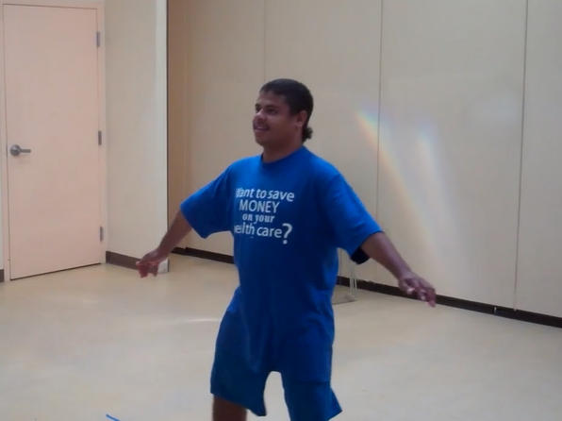

Figure 23: Student playing "Falling Faces"

For Hello Park, most of the students already understood the concept of waving and greeting a person. The therapist also commented that most of them say hello to their friends all the time at school. Thus, the primary learning benefit seemed to be that of performing a more proper or natural hand wave. One encouraging observation from a video showed a particular student waving his entire arm up and down without bending his elbow. The game was not registering his wave so the therapist modeled a more “proper” wave by moving her hand side to side while keeping her upper arm relatively stationary. The student was able to mimic the gesture while playing the game and receive the positive feedback (the character on screen waving back).

|  |  |
| --- | --- |
|  |  |

Figure 24: Student learning to correct his wave while playing "Hello Park"

## Emotionary Study

Emotionary was used with a total of 6 students over 3 consecutive days. The teacher/staff were instructed to have each student create an entry multiple times during the day, perhaps once in the morning and once in the afternoon. A total of 36 entries were created during the 3 days. 32/36 of the entries were tagged as “happy.” 35/36 entries included a photo of the student trying to express the emotion. 28/36 entries included a response for why they felt a particular emotion.

For entries that included a reason for feeling an emotion, responses were coded as either specific or vague. An example of a vague reason is, “I feel happy because I had fun.” An example of a specific reason is, “I feel happy because we did art.” 20 entries were coded as specific and 8 as vague. All students were able to connect their emotions with specific events, but some students did so more often than others. A confounding factor is the facilitator, which varied between the teacher and a particular staff member. Because sessions were not video recorded, it is impossible to determine how much of the responses were synthesized by learners and how much assistance the facilitators provided.

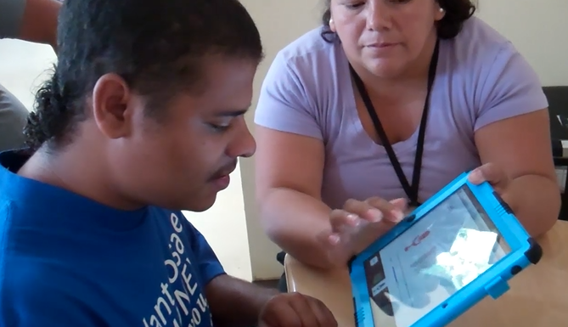

Figure 25: Student using Emotionary.

Because the duration of the study was so short, it is impossible to tell whether students were learning more about emotions or to be more reflective over time or not. It would be very interesting to see if students could elaborate in increasing detail over extended use of the app. More details could be possible evidence for students learning to extract contextual information relevant to their own emotions.

# Next Steps

Although our program ends in August 2012, we have decided to continue on with both of our projects, Me.Mu and Emotionary. For Me.Mu, we had recent discussions with the Pacific Autism Center of Education on possibly collaborating to expand and improve Me.Mu. For Emotionary, due to very positive feedback about how it could be used not only for those with autism but also for any individual who has trouble with emotions, we will be publishing it on the iPad app store sometime early Fall 2012. Before publishing it, we will comb through the feedback and suggestions provided to us by beta testers and implement the changes. After providing it for free on the App Store, we will continue to monitor its progress and make the proper changes. We may also apply to conferences and websites to feature our applications.

# References

American Psychiatric Association. (2000). Diagnostic and statistical manual of mental disorders (4th ed., text rev.). Washington, DC: Author.

Baron-Cohen, S., Golan, O., & Ashwin, E. (2009). Can emotion recognition be taught to children with autism spectrum conditions? Philosophical transactions of the Royal Society of London. Series B, Biological sciences, 364(1535), 3567-74. doi:10.1098/rstb.2009.0191

Hourcade, J. P., Bullock-Rest, N. E., & Hansen, T. E. (2011). Multitouch tablet applications and activities to enhance the social skills of children with autism spectrum disorders. Personal and Ubiquitous Computing, 16(2), 157-168. doi:10.1007/s00779-011-0383-3

Koegel, L. K. (1995). Communication and language intervention. In R. L. Koegel and L. K. Koegel (Eds.), Teaching children with autism: Strategies for initiating positive interactions and improving learning opportunities (pp. 17-32). Baltimore, MD: Paul H. Brookes.

Koegel, L. K., & Koegel, R. L. (1995). Motivating communication in children with autism. In E. Schopler and G. B. Mesibov (Eds.), Learning and cognition in autism (pp. 73-87). New York: Plenum Press.

Luckett, T., Bundy, A., & Roberts, J. (2007). Do behavioural approaches teach children with autism to play or are they pretending? Autism : the international journal of research and practice, 11(4), 365-88. doi:10.1177/1362361307078135

Media and Learning Group at SRI. (2010). Joint media engagement and learning. Menlo Park, CA: SRI International.

Strain, P., McGee, G, and Kohler, F. (2001). Inclusion of children with autism in early intervention settings. In. M. Guralnick (ed.), Early childhood inclusion: Focus on change. Baltimore: Paul Brookes Publishing.

Schreibman, L. (2007). Pivotal Response Training. Autism Podcast #57. (<http://www.autismpodcast.org/show_notes/50-75/57_laura_schriebman.htm>)

## Websites

Autism Speaks Inc. (2012). What is Autism. Retrieved February 9, 2012 from: <http://www.autismspeaks.org/what-autism>

Winner, Michelle Garcia. (2012). Introduction to Social Thinking. Retrieved from http://www.socialthinking.com/ what-is-social-thinking

# Acknowledgements

Thank you to….

Pacific Autism Center for Education (pacificautism.org)

* Silvia Pinto (Teacher)
* Olivia Krakower (Speech therapist)
* Kurt Ohlfs (Director)
* Beth Harmon (Speech Language Pathologist)

Associated Learning & Language Specialists (allsinc.com)

* Michelle Fong (Speech Language Pathologist)

Developmental Pathways (developmentalpathways.com)

* Rebecca Berry (Physical Therapist, Clinic Director)
* Diana Smith (Speech Language Pathologist)
* Camille Castillo Leach (Occupational Therapist)

All the parents, therapists, & students who tested and supported our project!

Microsoft, for awarding us a Kinect

Financial support from Mr. Reece Duca

Wendy MacKay’s guidance in CS377i – Prototyping Interactive Systems

David L. Jaffe in ENGR210 – Perspectives in Assistive Technology

Our advisers: John Willinsky, Daniel Schwartz, and Paulo Blikstein

# Appendices

**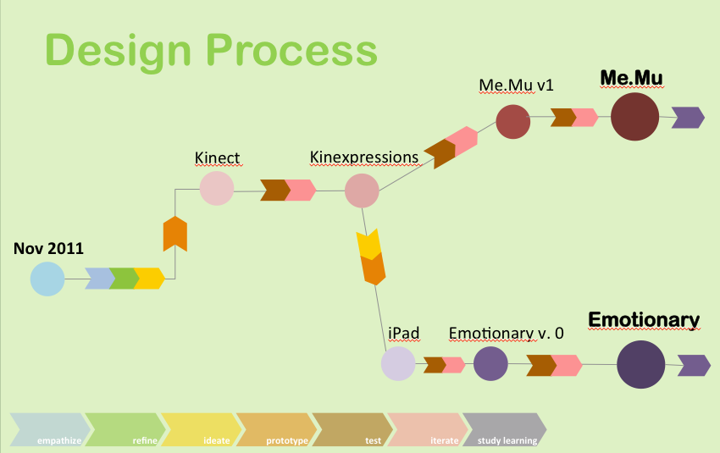**

Design Process Chart 1 for Our Master’s Project

**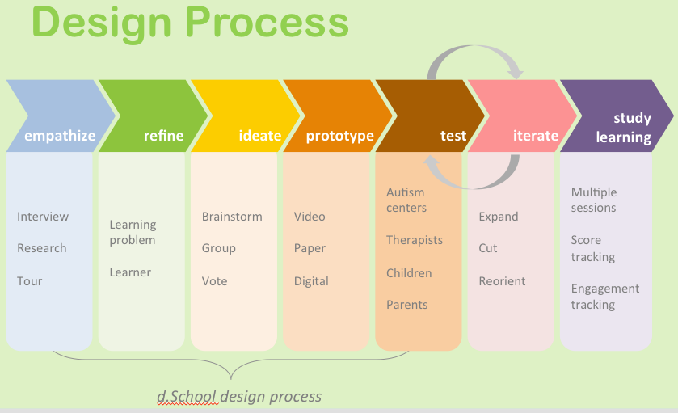**

Design Process Chart 2 for Our Master’s Project